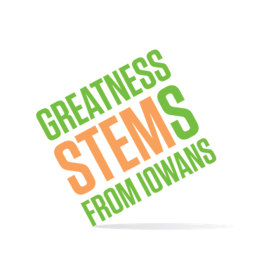
SC Region STEM Advisory Board
November 14th, 2019, 2:00-4:00pm
Palmers Deli Meeting Room
2843 Ingersoll Ave, Des Moines, IA 50312
Virtual attendees: Please click this URL to start or join. https://uni.zoom.us/j/526876645
Or, go to https://uni.zoom.us/join and enter meeting ID: 526 876 645
Join from dial-in phone line:
Dial: +1 646 558 8656 or +1 669 900 6833
Meeting ID: 526 876 645
November 14th, 2019
2:00 | Welcome
2:00-2:40 | STEM Strategies #Reboot February 11th, Ottumwa  Purpose: Update on action taken based on discussion at Oct. meeting regarding areas of high need and low Iowa STEM participation. Seek input on workshop content.
2:40-3:10 | Iowa STEM Externships – request for help expanding the program  Purpose: Expand this tool for catalyzing business/education partnerships. Share resources for board members to help.
3:10-3:35 | STEM Equity RFP  Purpose: Enlist board member networks to share RFP with potential providers and notify potential participants in the spring.
3:35-3:45 | Coming in spring: Scale-Up Apps, new STEM B.E.S.T. timeline, etc.  Purpose:
Announcements: | Next meeting: Tuesday, January 14th 1-3pm, Bondurant-Farrar Schools  Save the date for all board meetings this year:

SC STEM Advisory Board Schedule
Month | Day | Date | Time | Location
November | Thursday | 14 | 2-4p | Palmers on Ingersoll, Des Moines
December | No Meeting
January | Tuesday | 14 | 1-3p | Bondurant-Farrar CSD, Bondurant
February | Wednesday | 19 | 1:30-4:30p | Iowa State Capitol Complex, Des Moines
March | Wednesday | 11 | 1-3p
April | Monday | 13 | 1-3p
May | Monday | 11 | 1-3p | Facebook Data Center, Altoona
June | Tuesday | 16 | 1-3p | Iowa AgriTech Accelerator, Des Moines (tentative)

