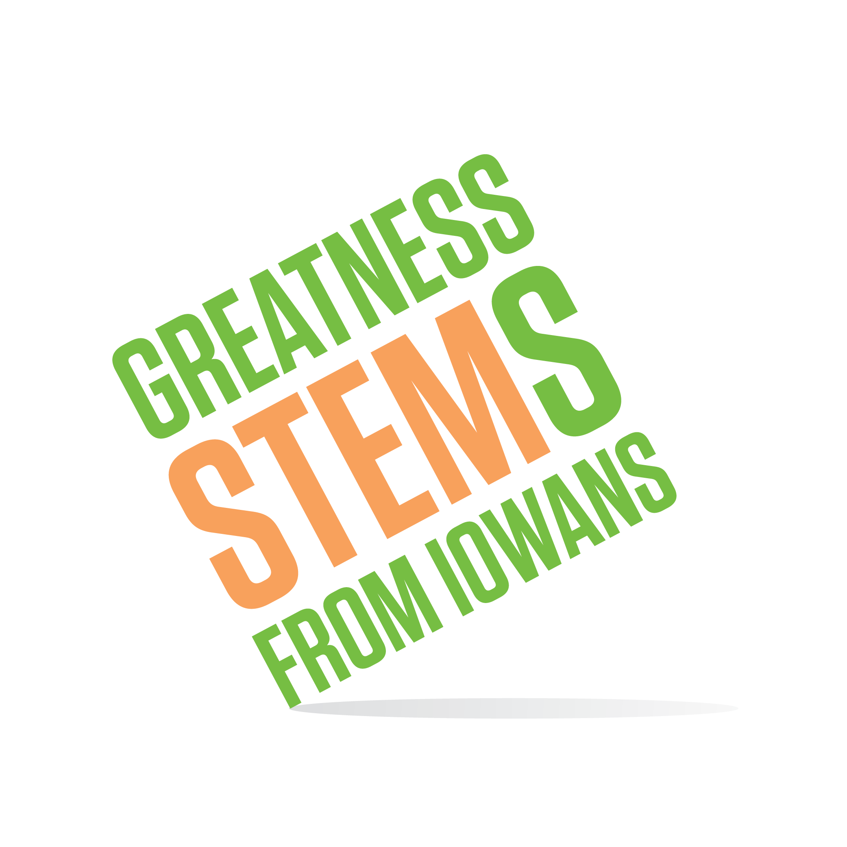
SC Region STEM Advisory Board
September 5, 2019, 1:00-3:00pm

Drake University
Olmsted Center, Drake Room (Upper level)
2875 University Ave, Des Moines, IA 50311

Virtual attendees: Please click this URL to start or join. https://uni.zoom.us/j/526876645
Or, go to https://uni.zoom.us/join and enter meeting ID: 526 876 645

Join from dial-in phone line:

Dial: +1 646 558 8656 or +1 669 900 6833
Meeting ID: 526 876 645
Thursday, September 5th, 2019
1:00-1:30 | Welcome all! Introductions and group building. Come prepared to share a key relationship that influenced your career path and/or decision to work in Iowa.  Purpose: Prepare for our work together this year by getting to know one-another and identifying common themes that support our mission of feeding Iowa’s STEM talent pipeline.
1:30-2:00 | Looking ahead – upcoming STEM opportunities to engage as board members.  Purpose: Preview the year ahead and form a plan for applying time and talents. See board engagement sign up.
2:00-2:15 | Introduce new Math Scale-Ups  Purpose: Inform and strategize for application recruitment to new audiences and leveraging this opportunity to influence a more mathematics positive culture.  More info: https://iowastem.gov/Scale-Up-Application
2:15-2:50 | STEM Networking Lunch & Learn model data – how can we leverage this model to reach new communities?  Purpose: Reflect on the Lunch & Learn pilot and advise on how to best apply the model to serve region needs.  Lunch & Learn pilot survey results
2:50-3:00 | New board chair/co-chair election  Purpose: Select the chair(s) for the year
Announcements: | Next meeting: Wednesday October 16th 3-5pm  Save the date: Wednesday, February 19th 10am-4pm: STEM Day at the Capitol (10a-2p) and MEGA meeting of all 6 regional boards (2:30p-4p)

