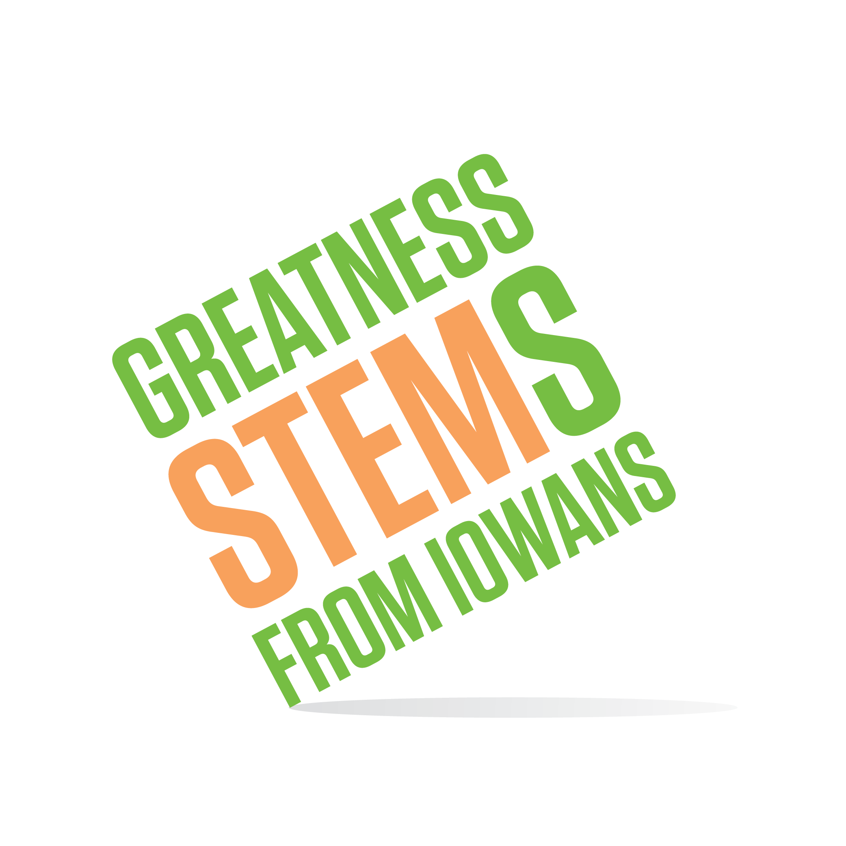
SC Region STEM Advisory Board
June 10, 2019, 2:00-4:00pm

Poweshiek County Extension
(Exact location pending)

Virtual attendees: Please click this URL to start or join. https://uni.zoom.us/j/526876645
Or, go to https://uni.zoom.us/join and enter meeting ID: 526 876 645

Join from dial-in phone line:

Dial: +1 646 558 8656 or +1 669 900 6833
Meeting ID: 526 876 645
Monday, June 10, 2019
2:00-2:20 | Welcome from Poweshiek County Extension Executive Director, Cathy Lents. Poweshiek Co Extension uses Scale-Up awards to reach youth across the county in and out of school.
2:20-2:35 | “Soapy Cilantro”: Genomics in middle and high schools. Dr. Pramod Mahajan will share the genomics experiment kit he has developed for 7-12th graders. This project is an example of K-12-Higher Education partnership (per our discussion of the challenges in this relationship last meeting), and the type of project for which the STEM Innovation fund was designed.
2:35-3:25 | Mathematics as a Magnet: special Math program call for proposals  - Call for reviewers (volunteer here)  - Timeline and action items  - Discussion: “Math Therapy”: what can we do to encourage math positive culture?
3:25-3:30 | Update on other programs augmented by late legislative appropriation to Iowa STEM.  - STEM Equity working group update
3:30-4:00 | STEM Networking Lunch & Learn model  - Register for June 12th Luncheon (by June 7th)  - What other communities in the region could benefit from an event like this? Identify targets for spring 2020.  - How to measure effect?
Announcements: | No July meeting. August meeting TBD after new board member appointments announced in July.

