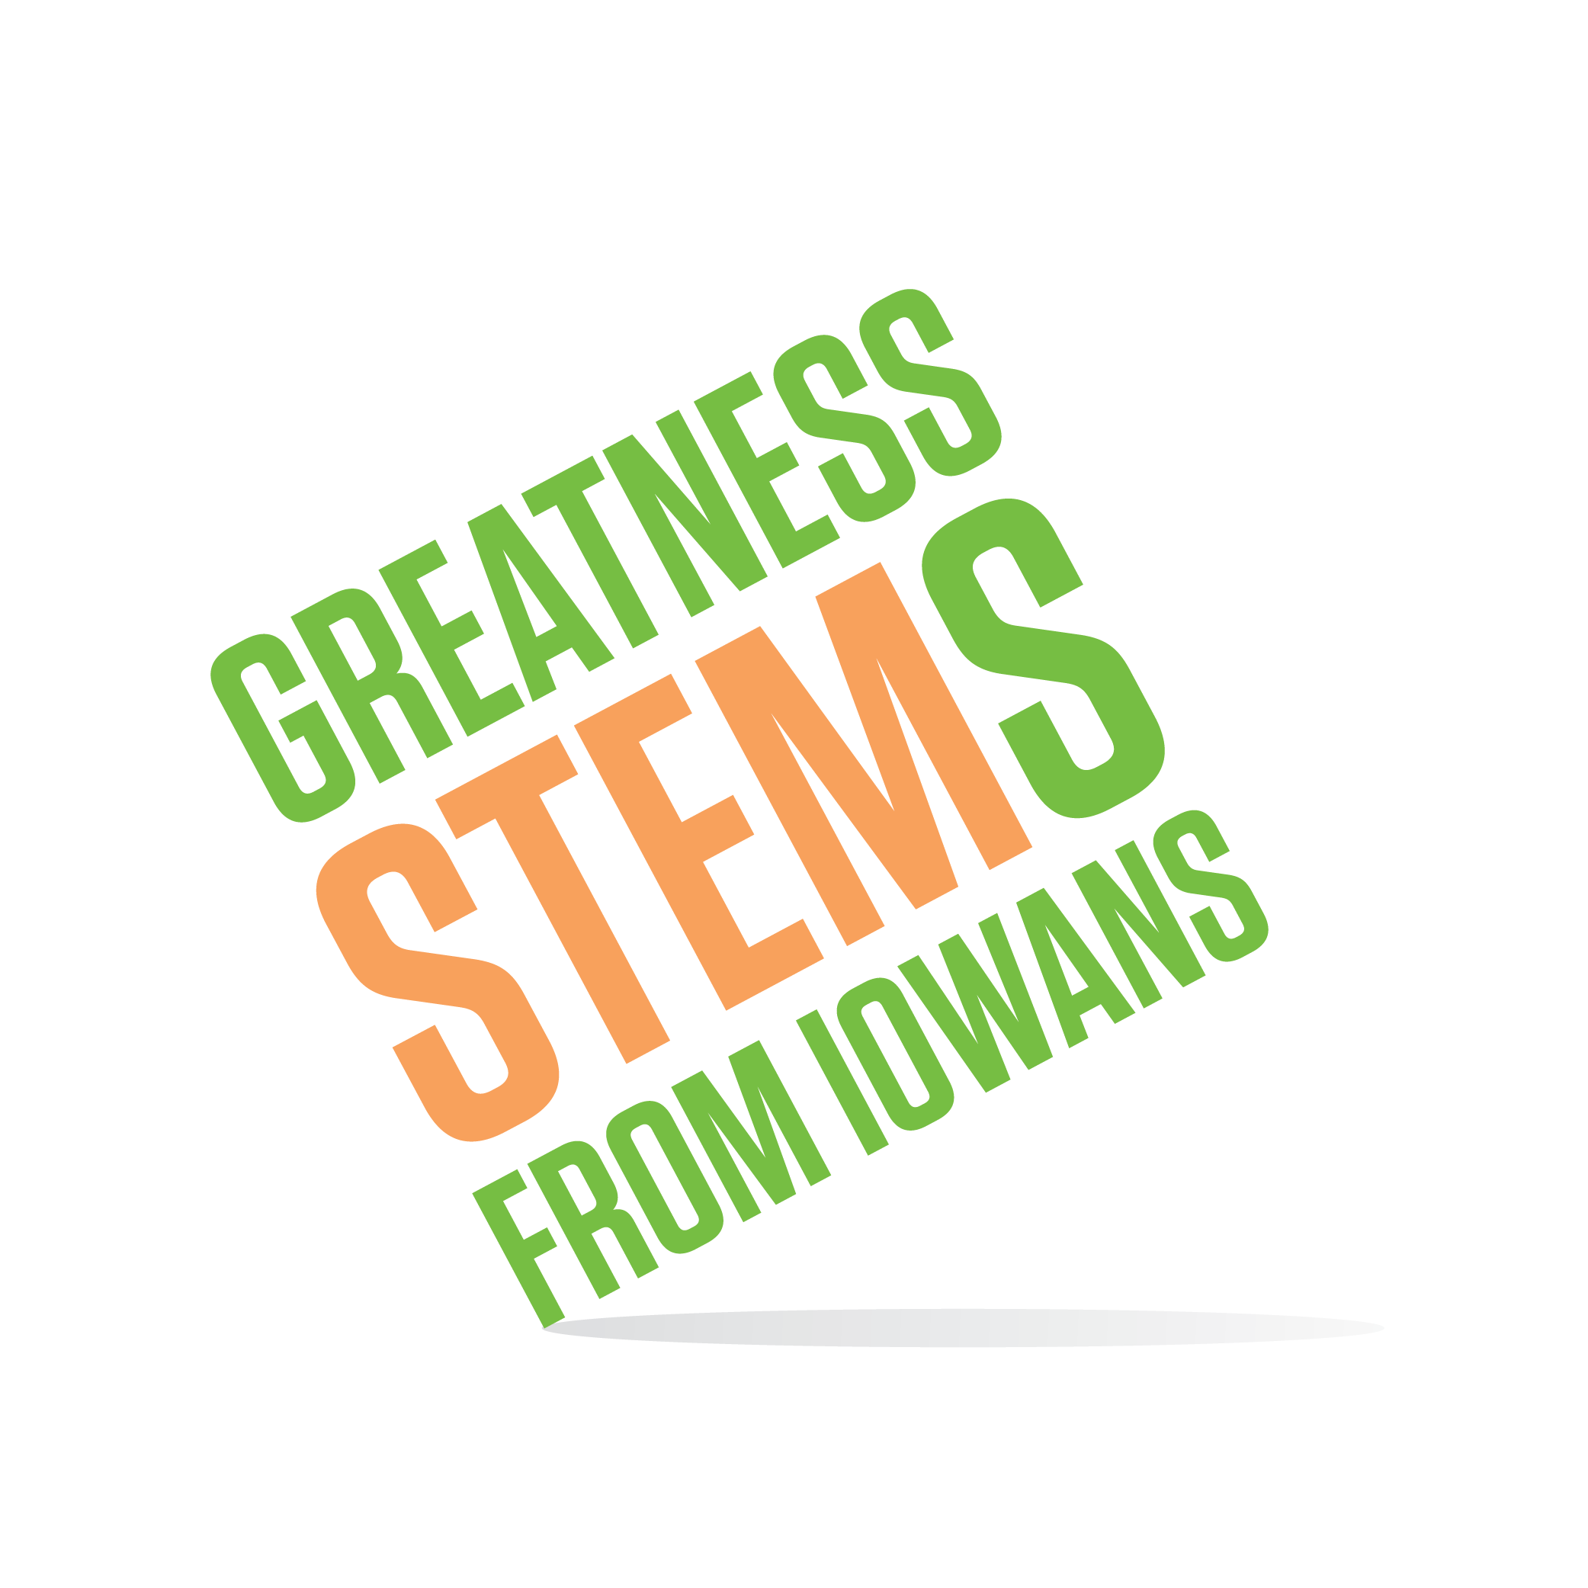
SC Region STEM Advisory Board
January 8, 3:30-5:30pm

Corteva (DuPont Pioneer)
Carver Building
7000 NW 62nd Ave, Johnston, IA 50131

Virtual attendees: You can join this event from a PC, Mac, iPad, iPhone or Android device:
Join Zoom Meeting https://zoom.us/j/5155353734
One tap mobile
+16468769923,,5155353734# US (New York)
Dial by your location
+1 646 876 9923 US (New York)
Meeting ID: 515 535 3734
Participant ID: Shown after joining the meeting
Tuesday, January 8, 2019
3:30-4:30 | Welcome and tour from Nadilia Gomez and our hosts at Corteva  Purpose: Gain knowledge of the STEM landscape throughout the region.
4:30-4:55 | Discussion: What skills are most important for a successful STEM career?  Purpose: Informally assess alignment between messages students receive about a strong STEM foundation and what industry seeks when hiring new employees in STEM careers. How can we promote that alignment through our STEM programs and our work as a board? Prior to this meeting, please make a point to ask the youth in your life “What skills are most important in a STEM career?”. Please come to the meeting with information about what your profession seeks when hiring for STEM-related jobs. Example sources: Current job postings, conversations with Human Resource representatives, high school/college graduation requirements, conversations with stakeholders…
4:50-5:15 | How does Iowa’s STEM work fit within the national STEM education context? A conversation with returning Iowa STEM Executive Director, Dr. Jeff Weld  Purpose: Get acquainted/re-acquainted. Jeff has spent the last year in Washington D.C. leading a collaboration to create America’s Strategy for STEM Education.
5:15-5:25 | 2019-2020 STEM Scale-Up Program Applications open January 21 – overview and promotional information.  Purpose: The Scale-Up Program is where the largest portion of the SC STEM Hub’s resources go. Equip all members to be ambassadors to equitably recruit applications from across the region. We can only award programs to those who apply.
5:25 | STEM Day at the Capitol – Feb 13th 10am-2pm– No SC Board meeting after.  Purpose: Brainstorm how best to demonstrate the SC Region’s impact and communicate the importance of continued support to our legislators. STEM Day at the Capitol is the annual Iowa STEM family reunion. Meet and experience Iowa STEM programs through students. SC Board meeting scheduled Feb 13th is canceled so board members can prioritize time for the events at the Capitol. Sign up to volunteer for STEM Day at the Capitol.
5:30 | Adjourn.  Next meeting: Tuesday, March 12th 3:30-5:30pm Scale-Up Awardee selection priorities determined at this meeting, we need your voice.

