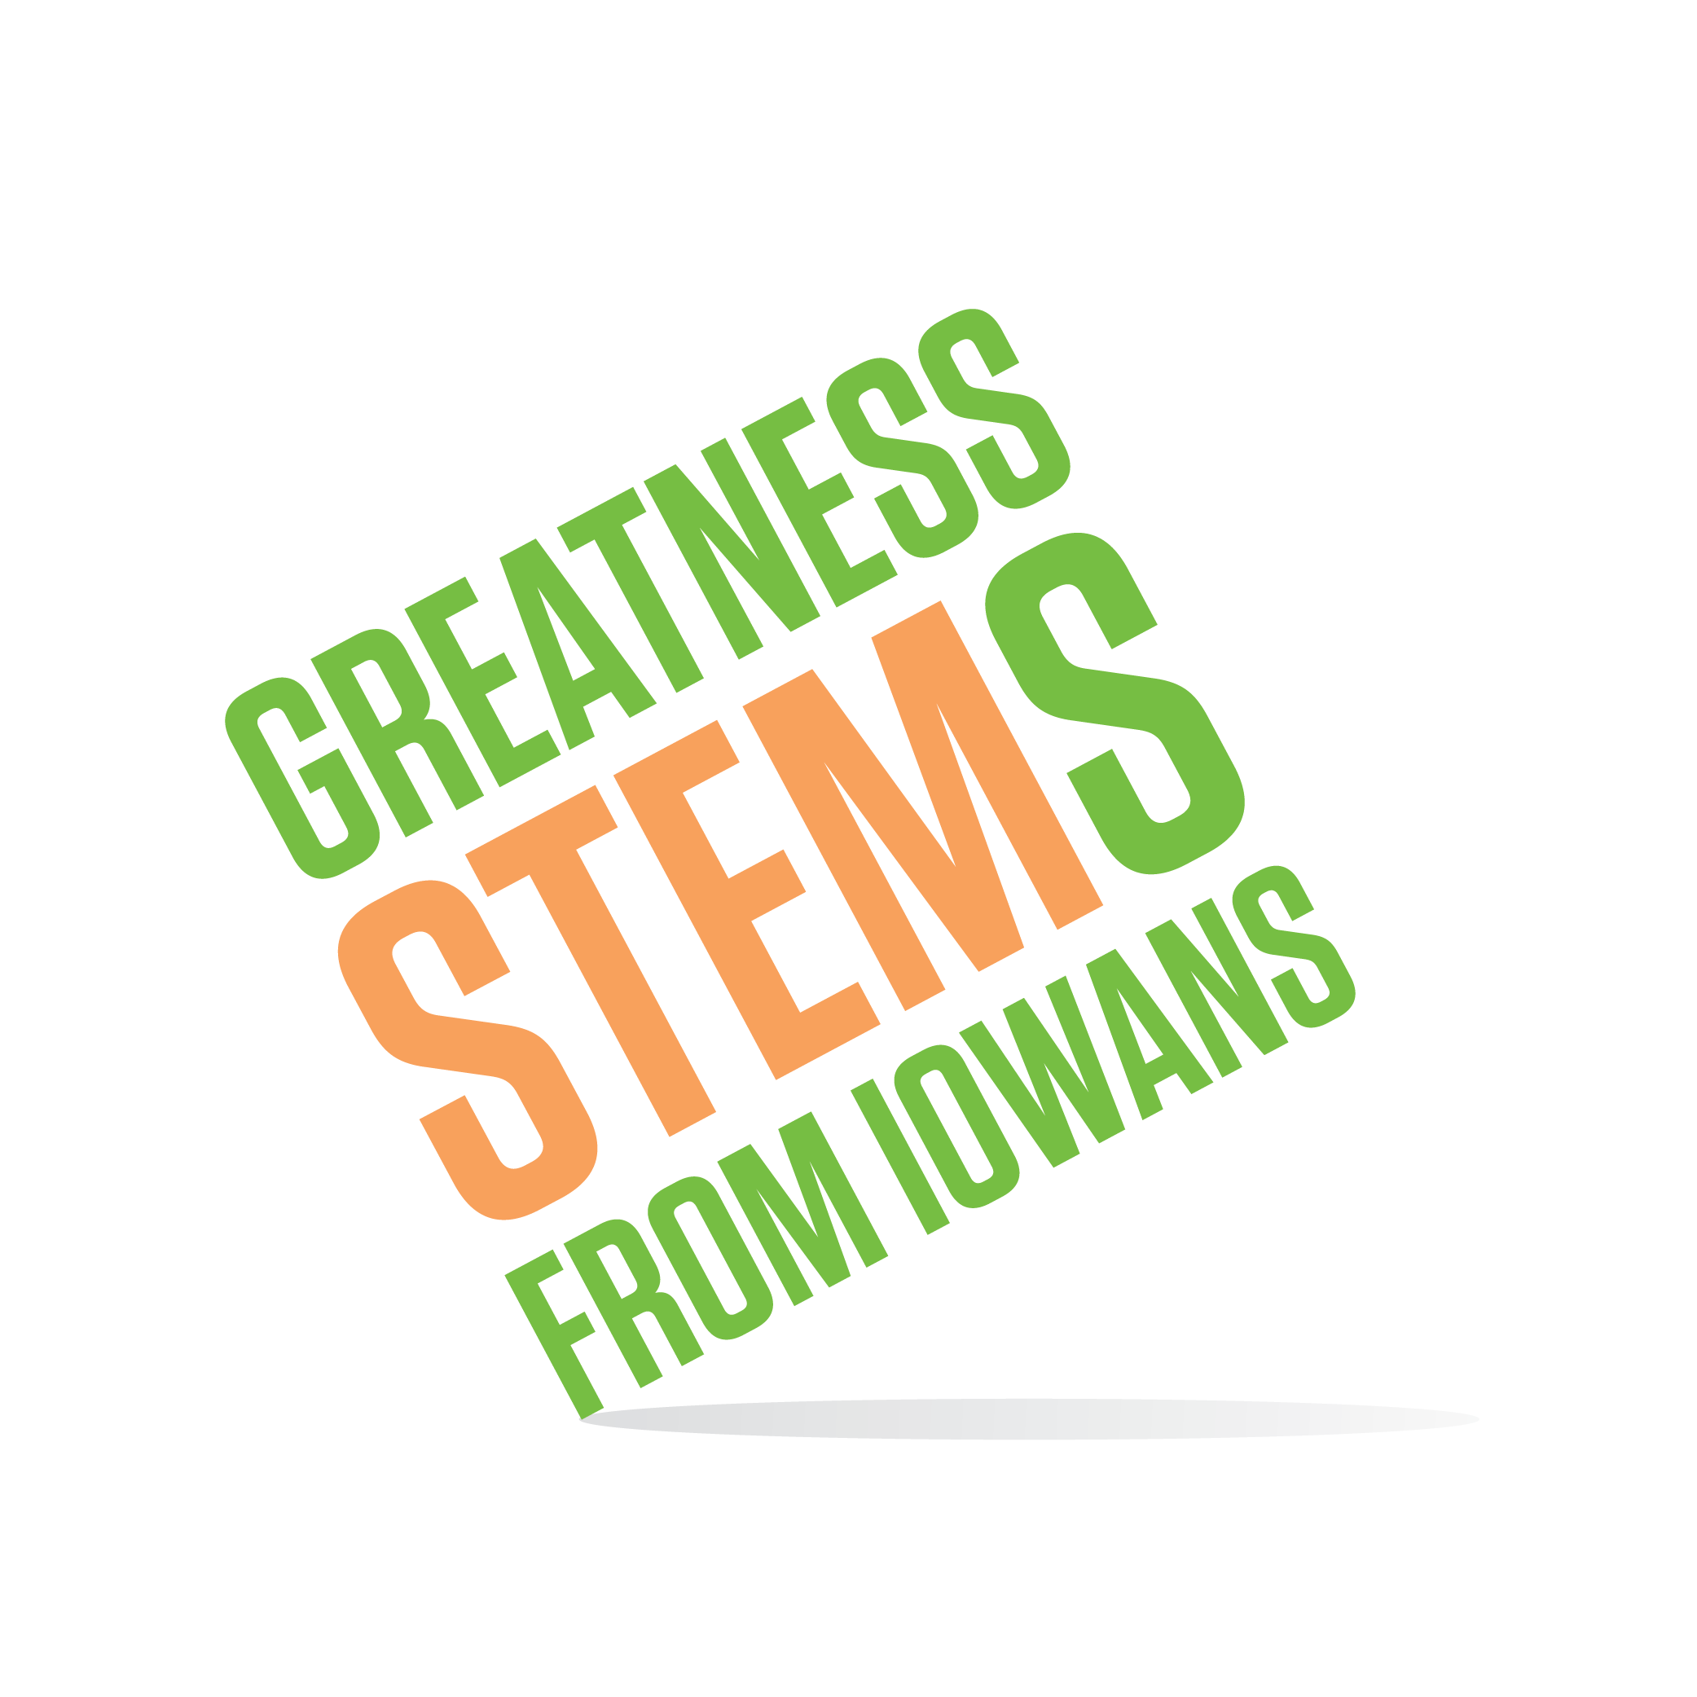

SC Region STEM Advisory Board
October 9, 2018 3-5pm

Simpson College, Kent Campus Center
701 N C St, Indianola, IA 50125 (map)
KCC Senate Room (second floor)

Virtual attendees: You can join this event from a PC, Mac, iPad, iPhone or Android device:
Please click this URL to start or join. https://uni.zoom.us/j/526876645
Or, go to https://uni.zoom.us/join and enter meeting ID: 526 876 645
Join from dial-in phone line:
Dial: +1 646 558 8656 or +1 408 638 0968
Meeting ID: 526 876 645
Participant ID: Shown after joining the meeting
Tuesday, October 9, 2018
3:00-3:20 | Welcome and STEM briefing from Simpson College – Thank you to our host, Dr. Jesse Wilcox  Purpose: Gain knowledge of the STEM landscape throughout the region.
3:20-3:30 | Future Ready Iowa Summits: Pella (complete), Centerville, Des Moines, and Ottumwa still open. Schedule and registration here.  Purpose: If you can attend Centerville, Des Moines, or Ottumwa as a board member, please let Sarah know if you’d be willing to speak at the November meeting. Share your reactions, questions, and thoughts on how this board can support the efforts.
3:30-4:15 | STEM Equity –resources for multiple stakeholder groups  Purpose: STEM Equity resources exist, but are often for a specific stakeholder group (teachers). If you have experiences or observances that are relevant to the following questions or help frame the discussion, please share your story.  - What makes a good resource?  - Share equity best-practices within your own stakeholder group.  - What to consider when trying to translate across stakeholder groups?
4:15-4:20 | Parting thoughts on your influence from Dr. Wayne’s dissertation
4:20-4:35 | STEM applications updates: STEM BEST, Scale-Up Provider, and Teacher Award  Purpose: Update board on program application status and participation numbers. If you are reviewing a program, would you be willing to share your experience as a reviewer with the group at our November board meeting? Respond to: What did you gain from being a reviewer? How can we improve the application? What would make the reviewer experience better? How do you recommend the advisory board support the selected programs, based upon what you read during the review process?
4:35-5:00 | Festivals conversation: October festivals, busing request, IMMAWII budget  Purpose: Seek board member advise (busing request), and participation (Oct 22, DMACC; Oct 27, Centerville; late January IMMAWII)  NOTE: We are still seeking exhibitors for both events. Do you have ideas for people or places to contact?
5:00 | Adjourn  Next meeting: Monday, November 12th 2-4pm, at Carlisle Middle School

