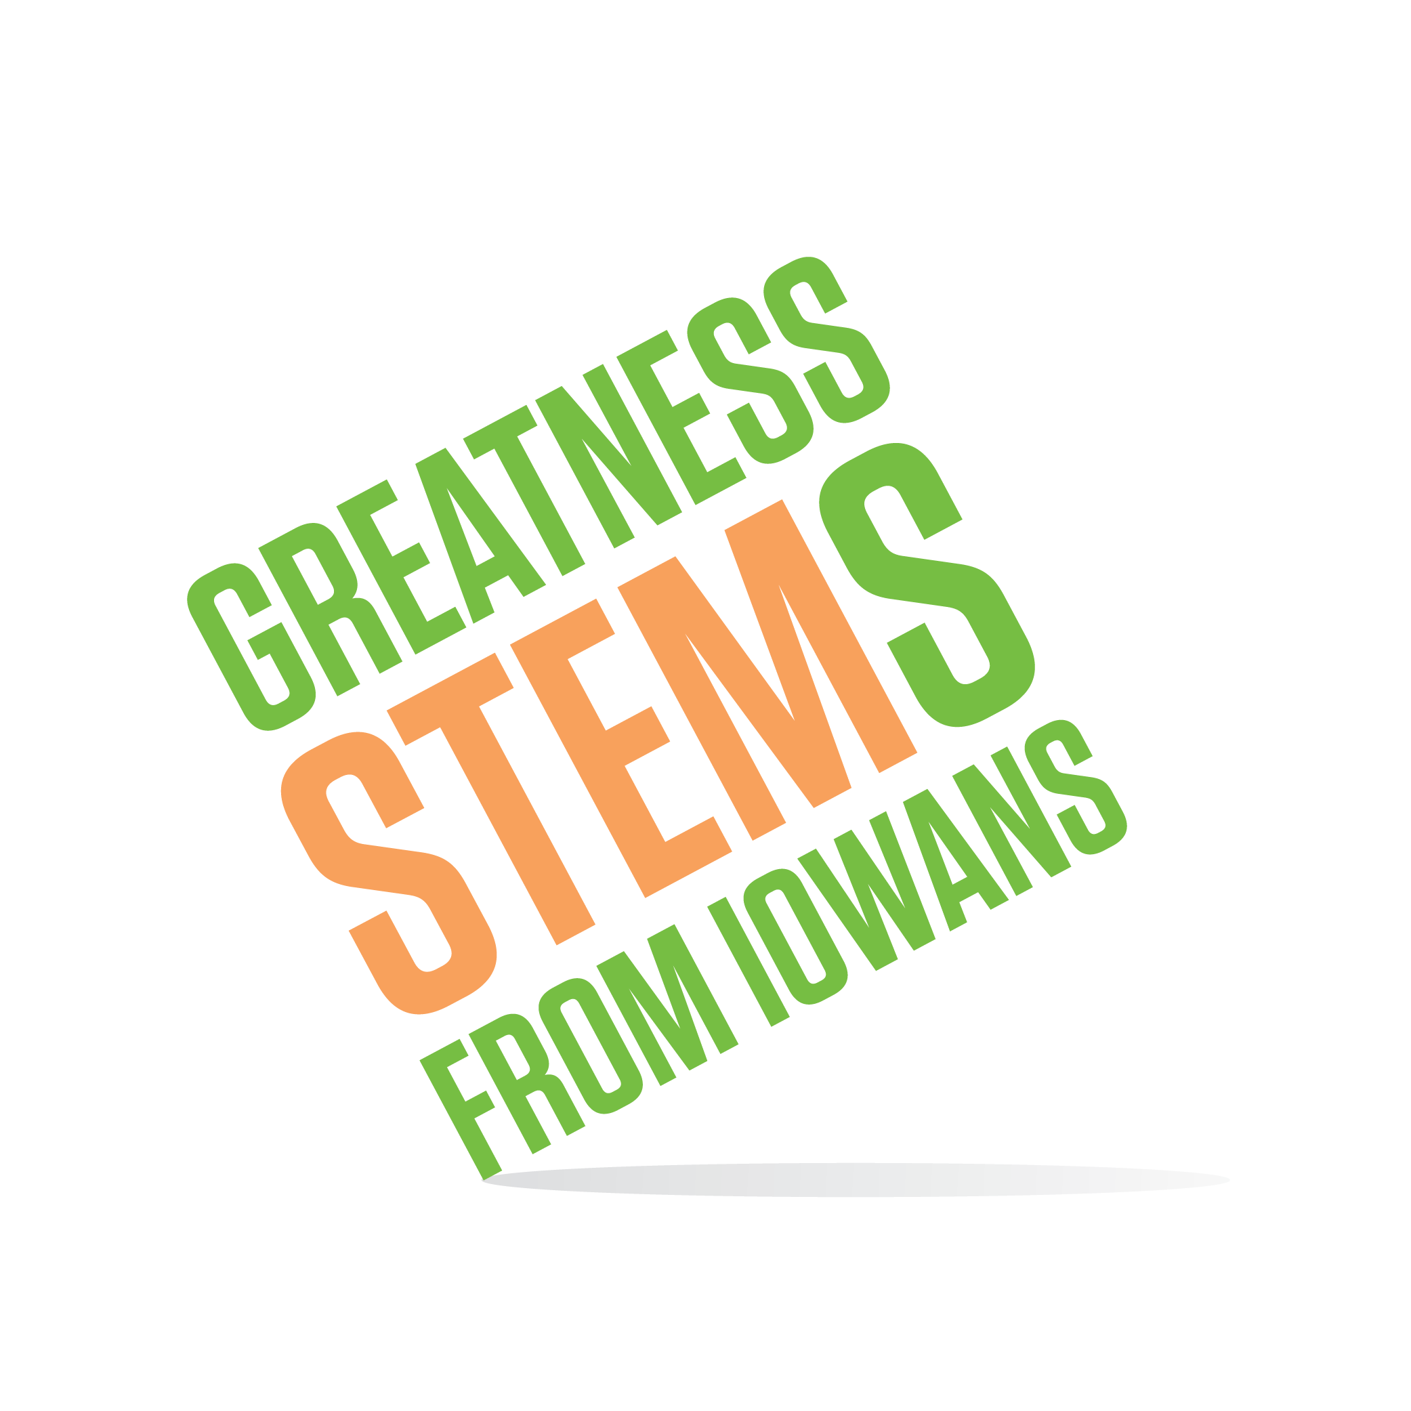

SC Region STEM Advisory Board
April 9, 2018 2-4pm
William Penn University
201 W Trueblood Ave, Oskaloosa, IA 52577
Musco Technology Center, Room 103

Virtual attendees: You can join this event from a PC, Mac, iPad, iPhone or Android device:

Please click this URL to start or join. https://uni.zoom.us/j/526876645

Or, go to https://uni.zoom.us/join and enter meeting ID: 526 876 645

Join from dial-in phone line:

Dial: +1 646 558 8656 or +1 408 638 0968

Meeting ID: 526 876 645

Participant ID: Shown after joining the meeting
Monday, April 9, 2018
2:00-2:30pm | Welcome from William Penn University (Breanne Garrett and Applied Tech Division of William Penn University)  Purpose: To become better informed about post-high school STEM opportunities in our region.
2:30-2:35pm | Introduction to Cindy Dietz, Interim Executive Director, Iowa Governor’s STEM Advisory Council  Purpose: meet our new leadership
2:35-3:15pm | Future Ready Iowa Summit Takeaways (Bontrager, Hensen, Pargmann, Johnson)  Conference attendees share two things from each session of the conference that they attended:  What do we (the board) need to know about that session?  What do we (the board) need to do?  Purpose: Learn about the landscape of STEM and Future Ready Iowa, state- and nationwide. Discuss strategies for the board to support the Future Ready Iowa initiative through the resources of STEM and our collective circles of influence.
3:15-4:00pm | Scale-Up Awardee Support (Garrett, Sieck, Hensen, Myerholz and all)  Purpose: Determine action steps for the board to support implementation and sustaining success for Scale-Up Awardees. How can we foster a long-term sense of connection between the awardees and the Hub?  Scale-Up Reviewers: As you reviewed applications, what were some hallmarks of strong applications and weak applications? Based on you review experience, how should we target our support?
4:00pm | Adjourn  Next meeting: Monday, May 14th 2-4pm

