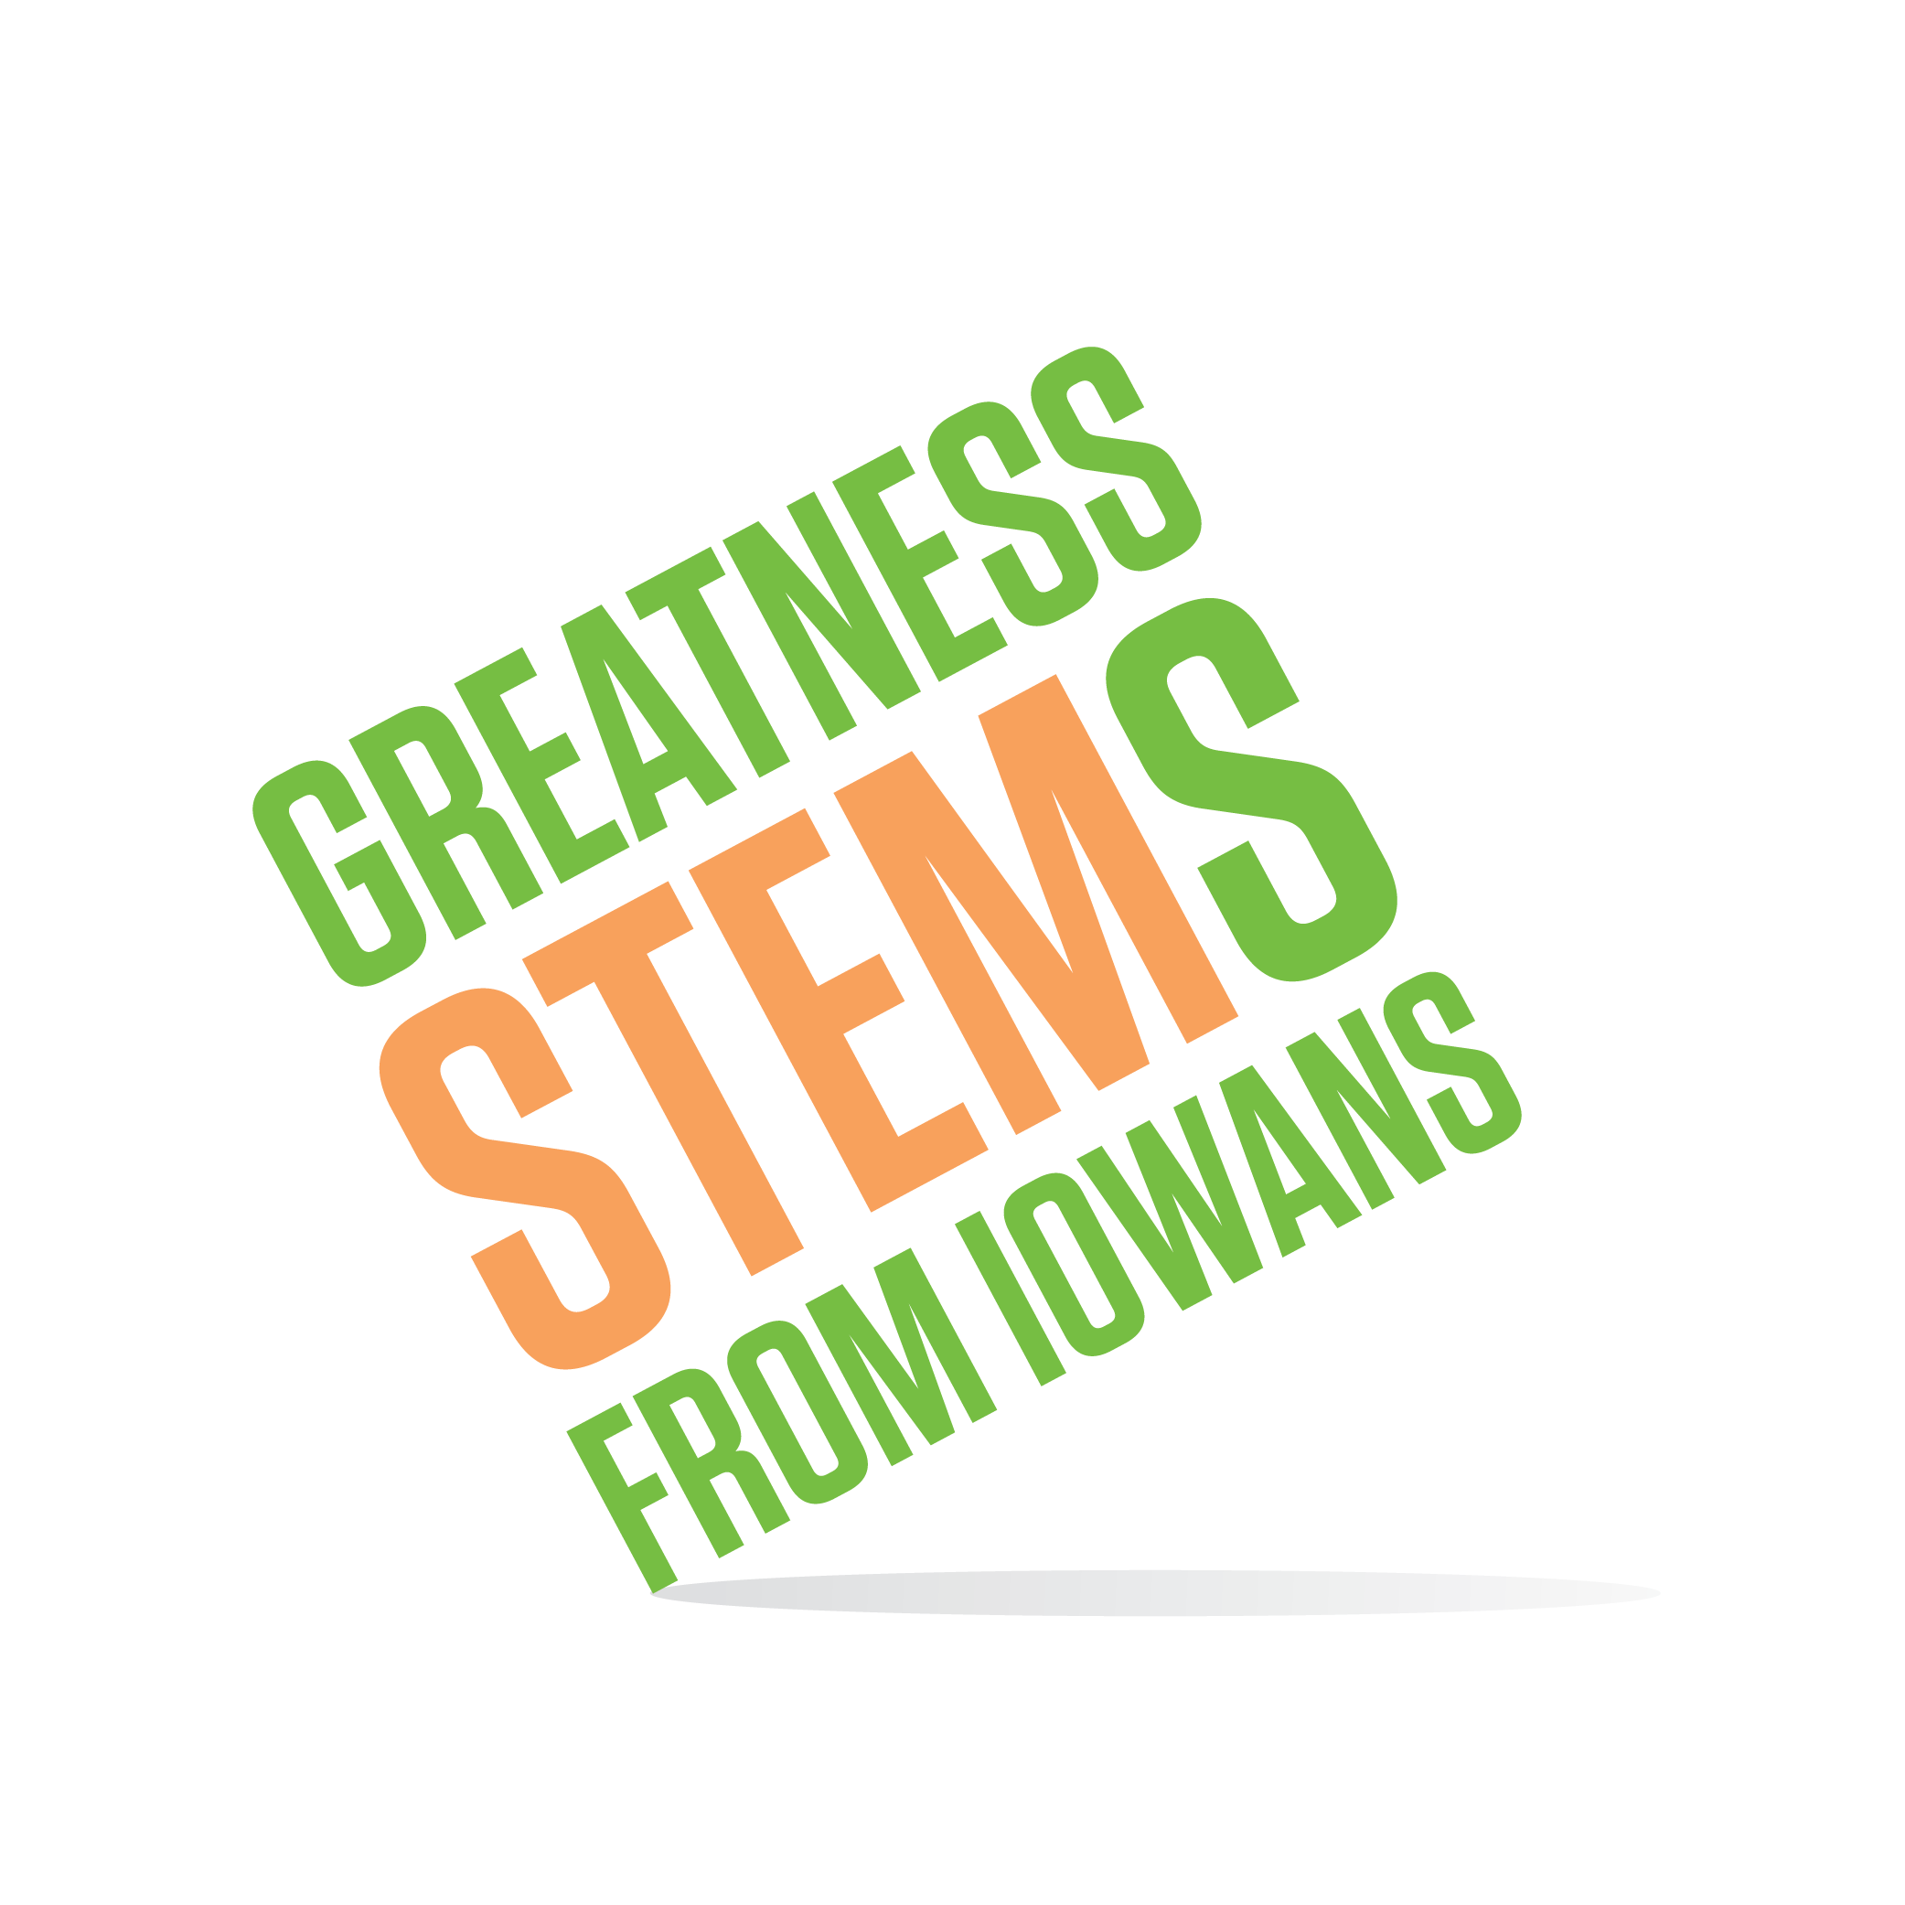
SC Region STEM Advisory Board
September 20, 2016
Cowles Library, Drake University, Des Moines
Room 201

Tuesday September 20, 2016
2:00-2:05 | Welcome  - Summarize August meeting outcomes
2:05-2:15 | Board Chair Annual Election  - Election by ballot
2:15-2:40 | The State of the Region Address  - Nuggets from 2015-2016 Eval Report  - South Central Distribution Maps  Scale-Up, STEM BEST, Festivals, etc  - Current SC Hub Activity  - Other community opportunities (board: where else could we plug in?)
2:40-3:00 | Set Measurable Goals and Prioritize  - How do the hub’s current activities align with those goals?
3:00-3:45 | Action Steps  - Strategies to reach goals  - Sub-committee tasks  - Schedule date to revisit
3:45-4:00 | STEM Updates  - Volunteers needed  - Dates for STEM Festivals  - Externship Information Session  - Announcements
4:00 | Adjournment  Next meeting: Wednesday, October 19th

