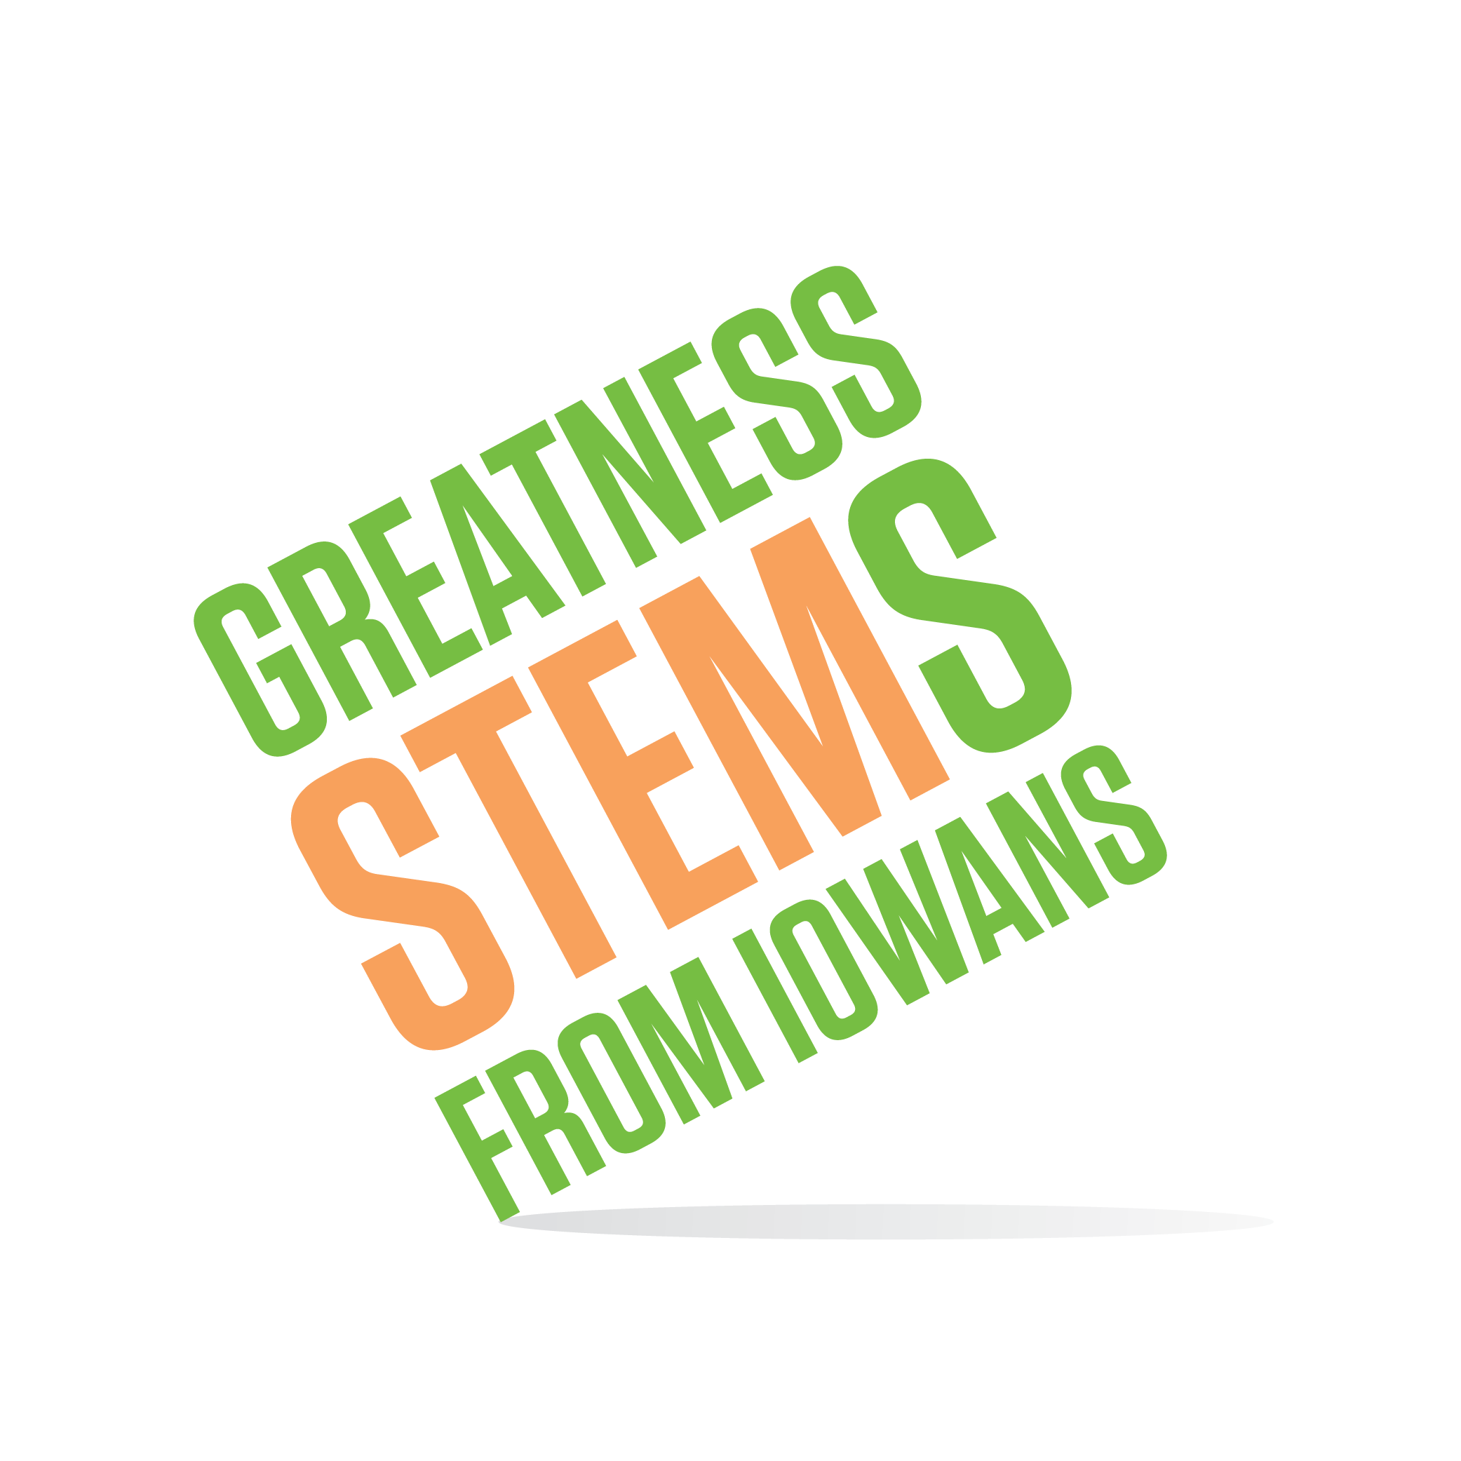

SC Region STEM Advisory Board
October 9, 2017 2-4pm
Valley High School
3650 Woodland Ave
West Des Moines, IA 50266
Room 1505 (between North Gym and Fieldhouse)

Virtual attendees: You can join this event from a PC, Mac, iPad, iPhone or Android device:

Please click this URL to start or join. https://uni.zoom.us/j/526876645

Or, go to https://uni.zoom.us/join and enter meeting ID: 526 876 645

Join from dial-in phone line:

Dial: +1 646 558 8656 or +1 408 638 0968

Meeting ID: 526 876 645

Participant ID: Shown after joining the meeting
Monday, October 9, 2017
2:00 | September re-cap  Goal: Update board on STEM Hub activities, including Twin Cedars STEM Festival, new Festival resources for exhibitors and parents, ACESSE Conference, Scale-Up Budget Update.
2:20 | 2016-2017 STEM Monitoring Report highlights  Goal: Inform the board of most recent data related to the state of STEM in Iowa, and Scale-Up progress to date.
2:45 | Setting priorities for South Central Iowa STEM in FY18  Goal: Identify areas of STEM need in the SC region with the goal of setting priorities for SC resource distribution. How will we measure success?
3:45 | Board member engagement/Upcoming events  Goal: Inform board members of current promotions and upcoming opportunities to engage in Iowa STEM activities this month and beyond. Fill any gaps and address questions.
3:45 | Poll interest in a Mega Meeting (a meeting of all 6 regional advisory boards’ membership)  Goal: Gather information about interest and what might be helpful to the 2017-2018 South Central STEM Advisory board at such a meeting.
4:00 | Next meeting: November 27th

