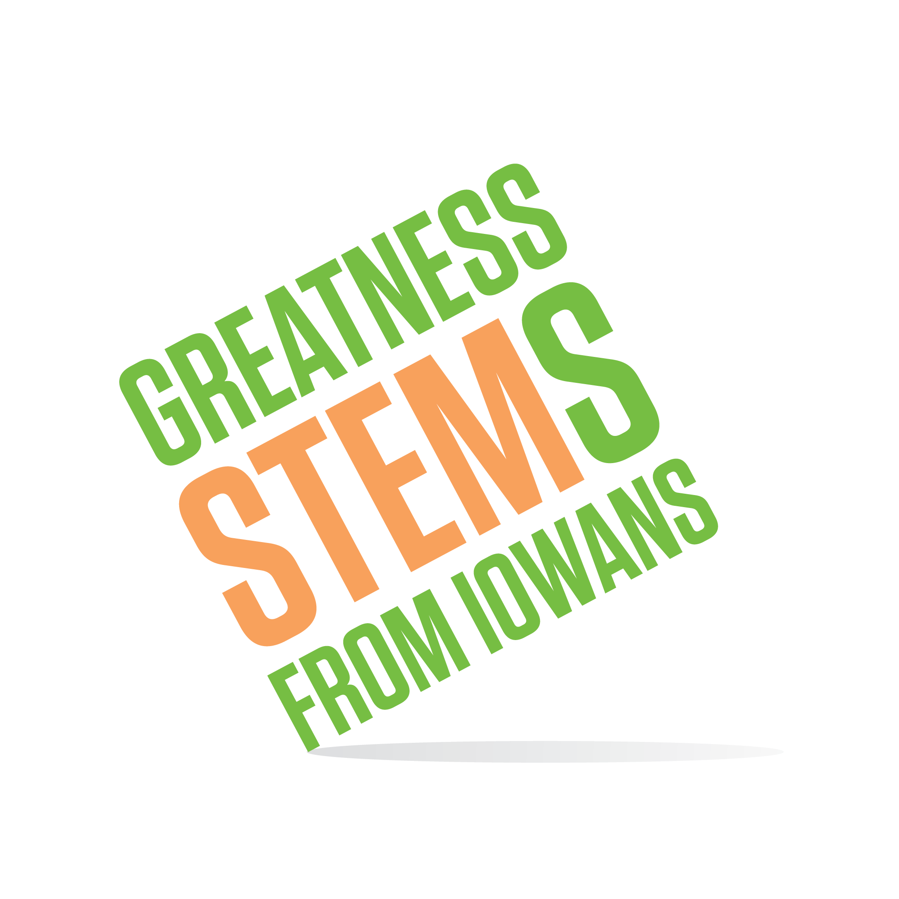

SC Region STEM Advisory Board
June 19, 2017

Waukee Innovation and Learning Center

Top Hat Room
3199 Ashworth Rd, Waukee, IA 50263

Virtual attendees: You can join this event from a PC, Mac, iPad, iPhone or Android device:

Please click this URL to start or join. https://uni.zoom.us/j/526876645

Or, go to https://uni.zoom.us/join and enter meeting ID: 526 876 645

Join from dial-in phone line:

Dial: +1 646 558 8656 or +1 408 638 0968

Meeting ID: 526 876 645

Participant ID: Shown after joining the meeting

Monday, June 19, 2017
2:00 | Welcome and Introductions from the Waukee Learning Innovation Center  Goal: Strengthen the board’s understanding the STEM B.E.S.T. model in practice as we promote STEM B.E.S.T. RFP this summer.  Hosts: Waukee APEX Program
Publishing our progress
Goal: Review the Hub’s strategies for measuring impact of region-specific activities (ex: STEM Festivals and the Checkout Inventory). Revise for improvement to data collected and response rate.
Celebrating our success
Goal: This is our last meeting for FY17. Celebrate our work together.
4:00 | Next meeting:  August 2017 – date/time to be determine after new board members are appointed (July)  No July meeting

