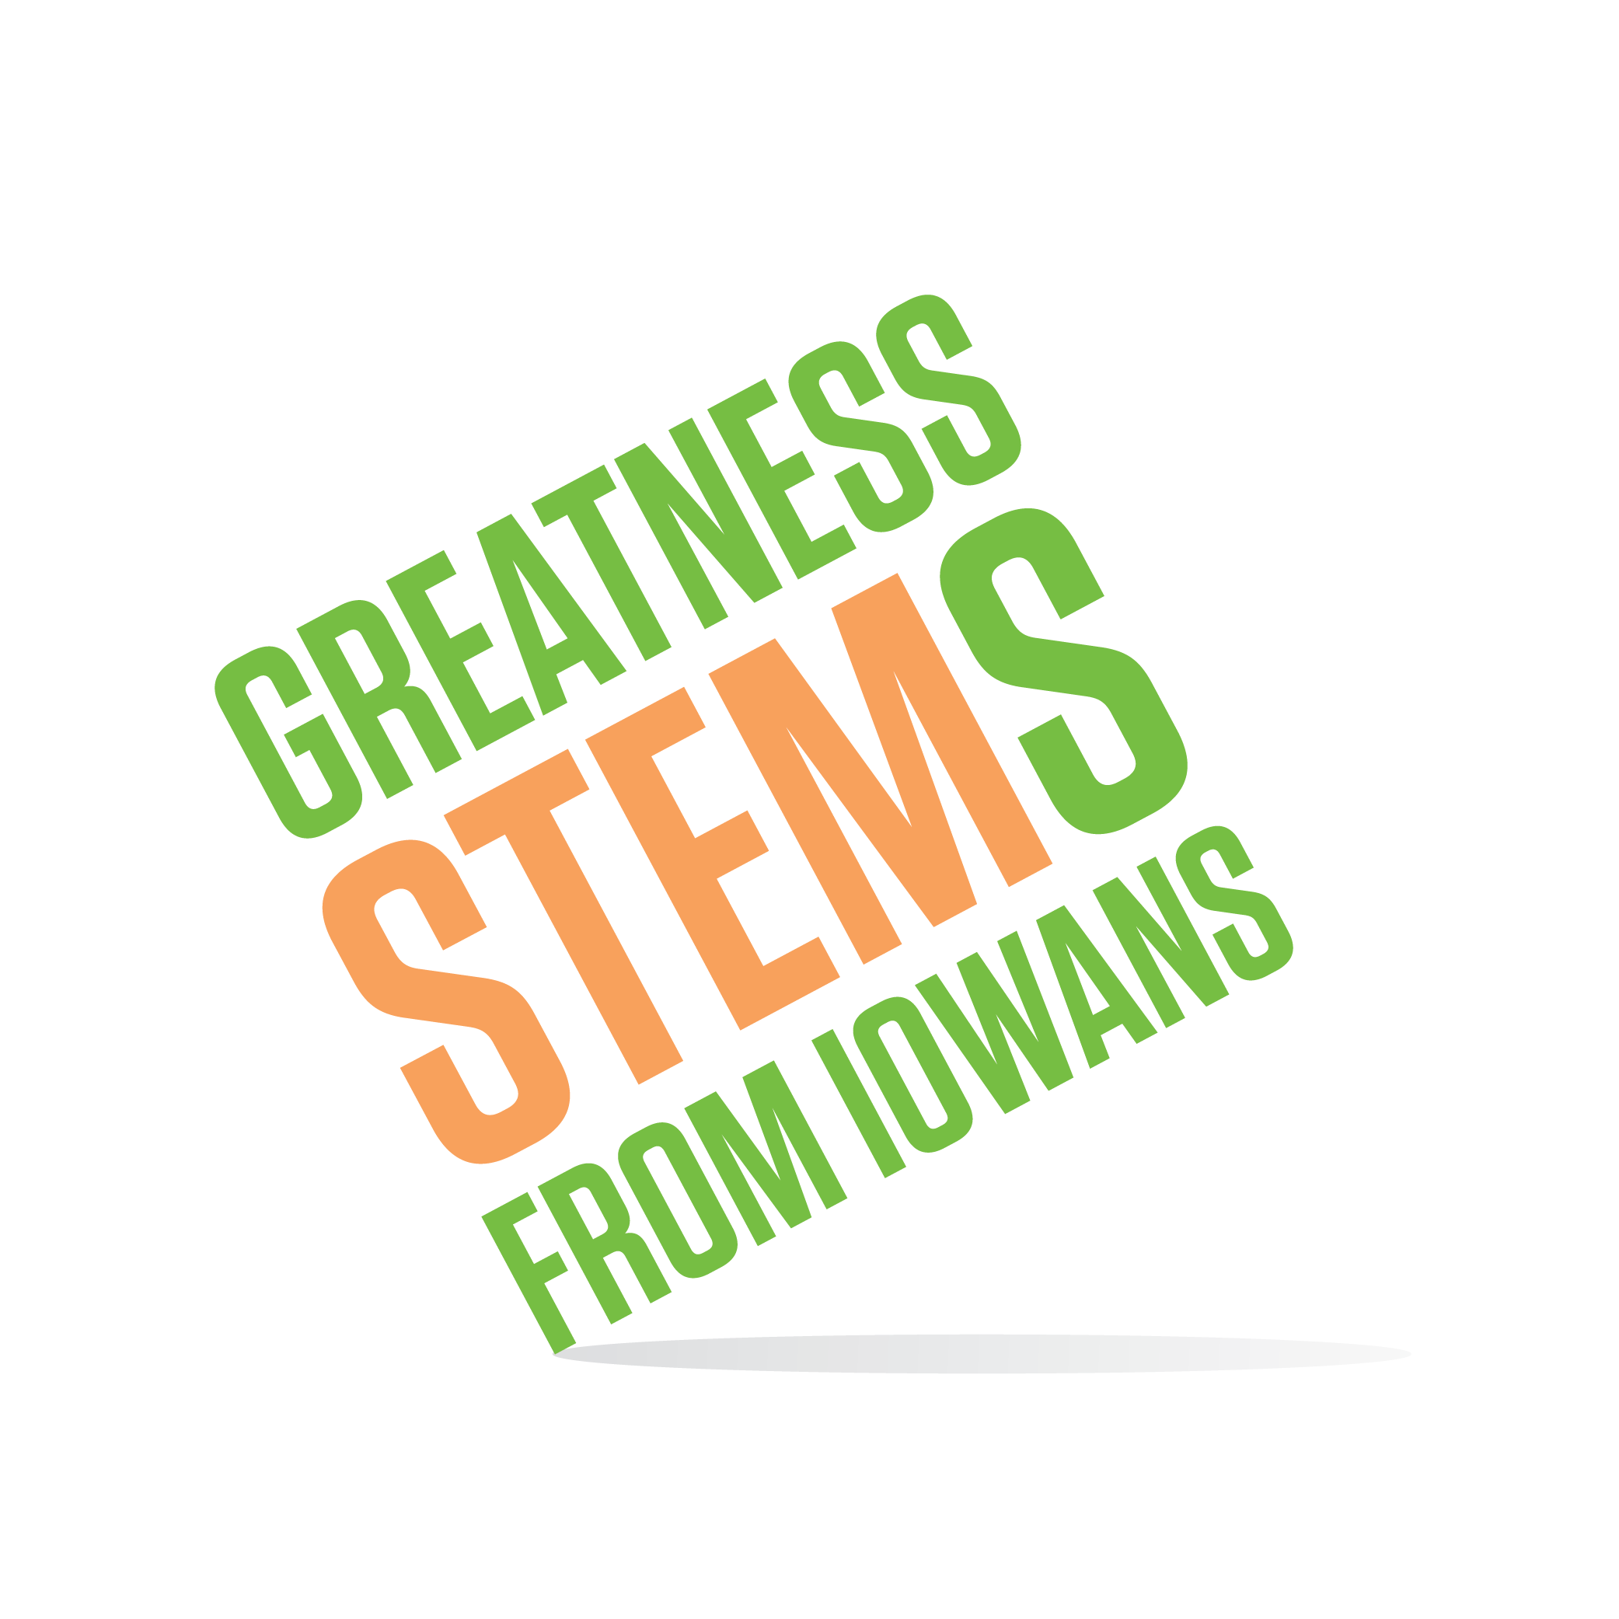

SC Region STEM Advisory Board
May 17, 2017

Sacred Heart School

1601 Grand Ave, West Des Moines

Virtual attendees: You can join this event from a PC, Mac, iPad, iPhone or Android device:

Please click this URL to start or join. https://uni.zoom.us/j/526876645

Or, go to https://uni.zoom.us/join and enter meeting ID: 526 876 645

Join from dial-in phone line:

Dial: +1 646 558 8656 or +1 408 638 0968

Meeting ID: 526 876 645

Participant ID: Shown after joining the meeting

Wednesday, May 17, 2017
2:00-2:30 | Welcome and Introductions and Makerspace Tour  Goal: build and grow the relationships of the STEM network  Hosts: Sacred Heart School
2:30-3:00 | Closing out FY2016 - remaining funds and hub checkout inventory Goal: resolve use of remaining funds and hub inventory reduction
3:00-3:30 | Media toolkit and SC calendar update  Goal: learn/explore the new STEM media toolkit so that board members are equipped to use it.
3:30-4:00 | SC STEM Advisory Board 2017-2018  Goal: generate options/ideas for new board member onboarding. Any missing stakeholders to recruit to board? Applications due June 9th.
Next meeting:
August 2017 – date/time to be determine after new board members are appointed (July)
No July meeting

