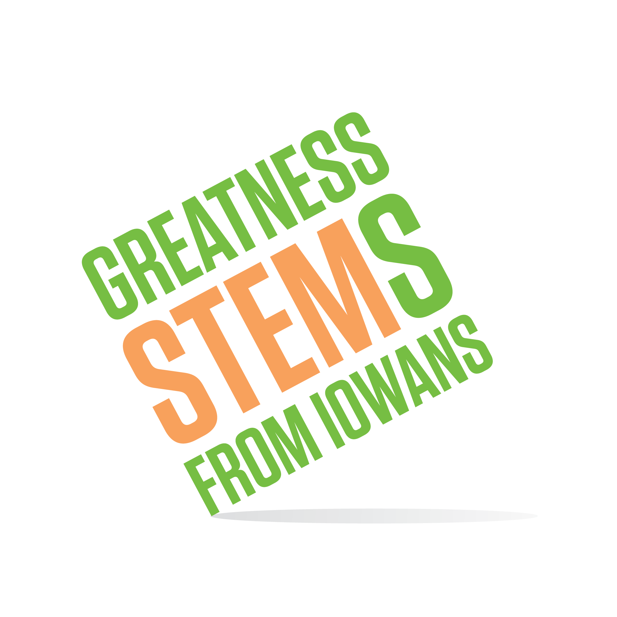
SC Region STEM Advisory Board
April 25, 2016
The Business Record, Des Moines
Monday, April 25, 2016
2:00 pm | Welcome from our hosts at The Business Record and roll call
2:05-2:10 | SC STEM April Activities Update  - Future Ready Iowa Summit and STEM BEST  - I.O.W.A. STEM Teacher Award  - STEM Town Hall at St. Theresa  - Festivals – South Tama and DM Metro/Drake
2:10-2:15 | Sub Committee Review
2:15-3:15 | Sub Committee Breakout time  - Set sub committee priorities  - Action items before June 30, 2016 and before June 30, 2017
3:15-3:30 | Sub Committee Share Out and Feedback
3:30-3:45 | Working smarter not harder – maximize hub efficiency  - Database experience/recommendations?  - Pro-tips/suggestions?
3:45-4:00 | STEM in your world
4:00 pm | Adjournment  Next Meeting:  Tuesday, May 24 9:30-11:30am Indianola, IA  Monday, June 27 2:00-4:00pm Location TBD (volunteers?)

