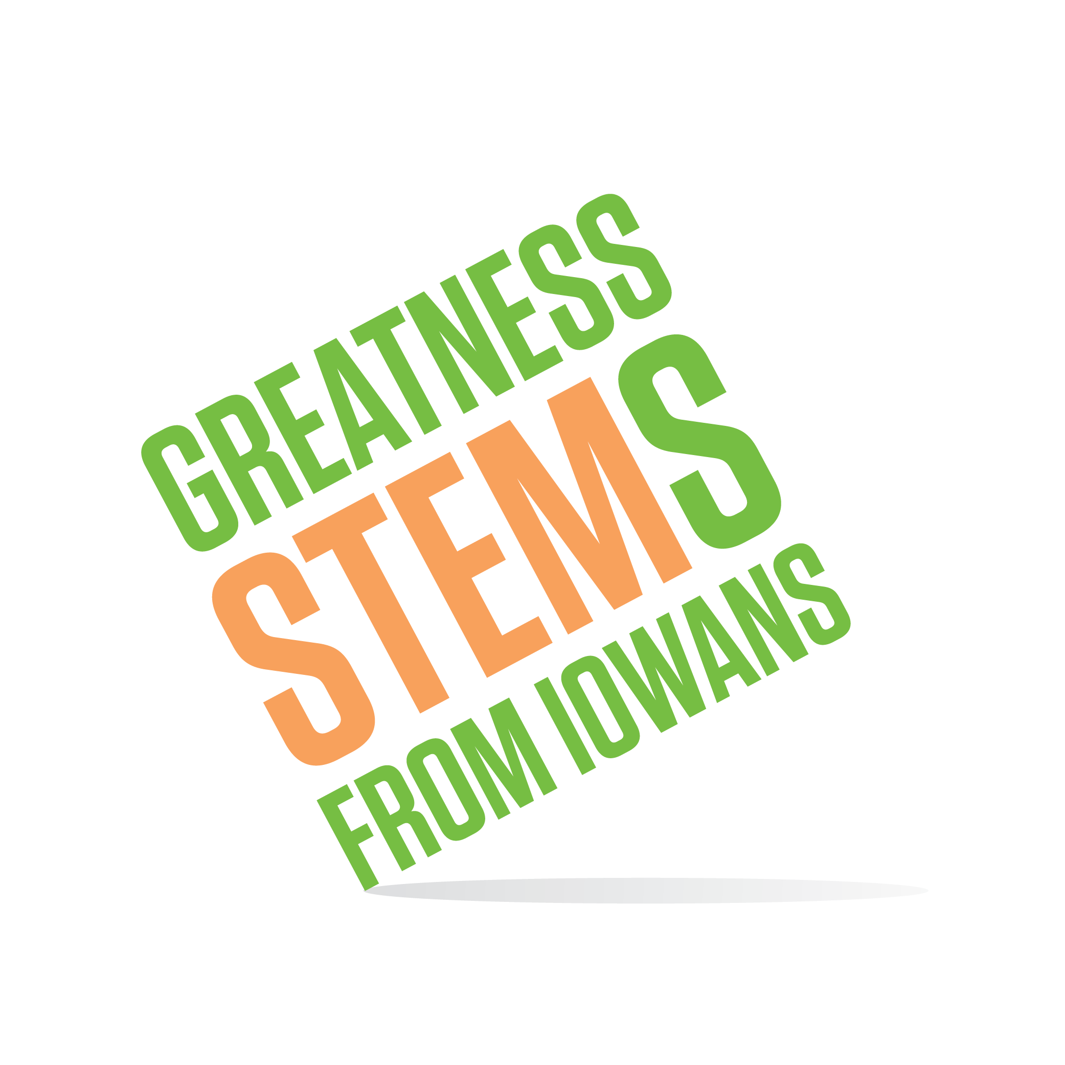
SC Region STEM Advisory Board
March 22, 2016
DuPont Pioneer, Johnston
Tuesday, March 22, 2016
9:30am | Welcome and roll call
9:30-10:00 | SC STEM Scale-Up 2016-2017 Awardees  - Selection Criteria  - Awardee list and map  - Next steps  - Engaging those not selected…
10:00-10:45 | Festivals 2016-2017  - Interested partners and festival priorities  - Festival capacity - time, budget  - Communicating expectations – Festival Planning Guide
10:45-11:00 | Sub Committee Breakout time  - Set sub committee priorities  - Action items before June 30, 2016 and before June 30, 2017
11:30am | Adjournment  Next Meetings:  Monday, April 25 2-4pm Des Moines, IA  Tuesday, May 24 9:30-11:30am Indianola, IA

