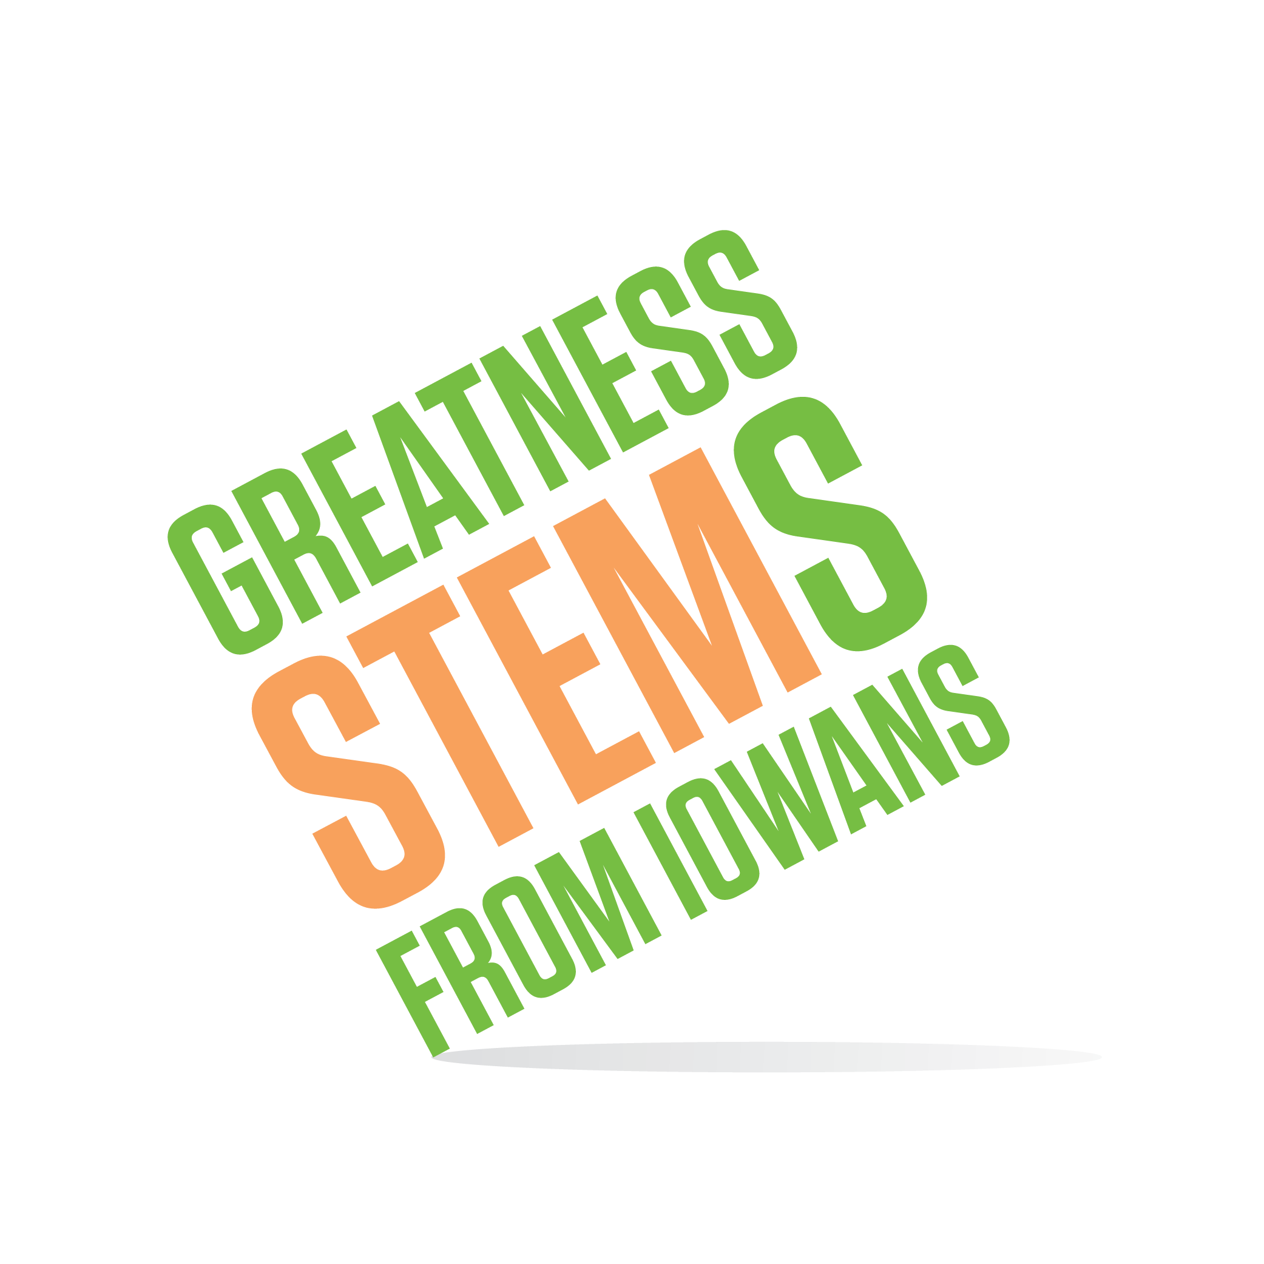
SC Region STEM Advisory Board
October 19, 2016
Hoover High School, Des Moines
STEM Room

Wednesday October 19, 2016
2:00-2:05 | Welcome
2:05-3:05 | STEM B.E.S.T. Review  - History and this year’s timeline  - 3 candidates  - Overview and discussion  - Next steps?
3:05-3:45 | SC STEM FY2017 Goals cont…  - Recap discussion from 9/20/16  - Set 2-3 measurable goals and baseline
3:45-4:00 | STEM in your world updates/Announcements  - Centerville Festival 10/22 from 10am-1pm  - DMACC Ankeny Festival 10/24 from 6-8pm  - BGM Festival 11/13 time TBD  - Your announcements…
4:00 | Adjournment  Next meeting: Monday, November 21 2-4pm at Crestview Elementary in West Des Moines (Maker Space visit + meeting)

