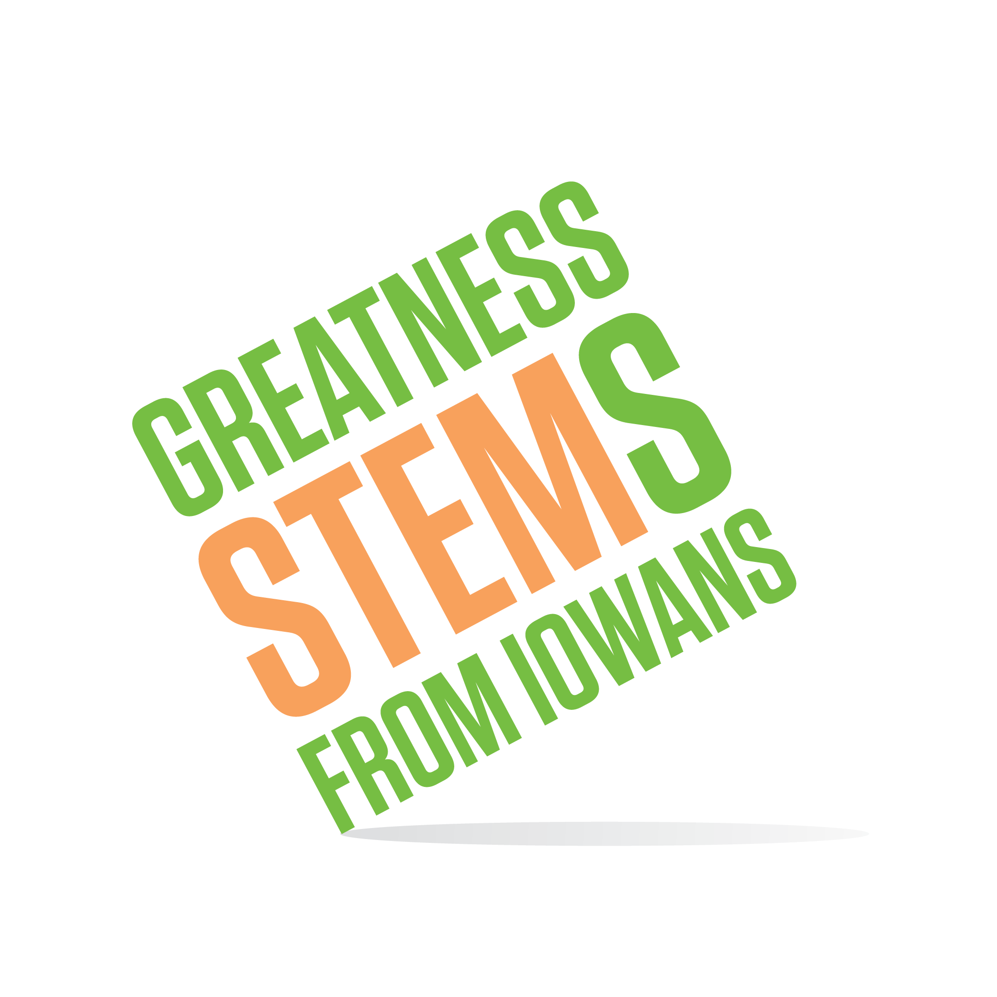
SC Region STEM Advisory Board
January 26, 2016
Virtual meeting via Zoom.us
Tuesday, January 26, 2016
9:30am | Welcome and roll call
9:35-10:15 | SC STEM Mid-Year Report  - Questions, strengths, areas to strengthen  - Goals
10:15-10:30 | STEM Scale-Up 2016-2017 Programs  - Menu Overview  - Materials for promotion  - Target audiences?
10:30am | Adjournment  Next Meetings:  Monday, February 22 2-4pm Des Moines, IA  Tuesday, March 22 9:30-11:30am DuPont Pioneer, Johnston, IA

