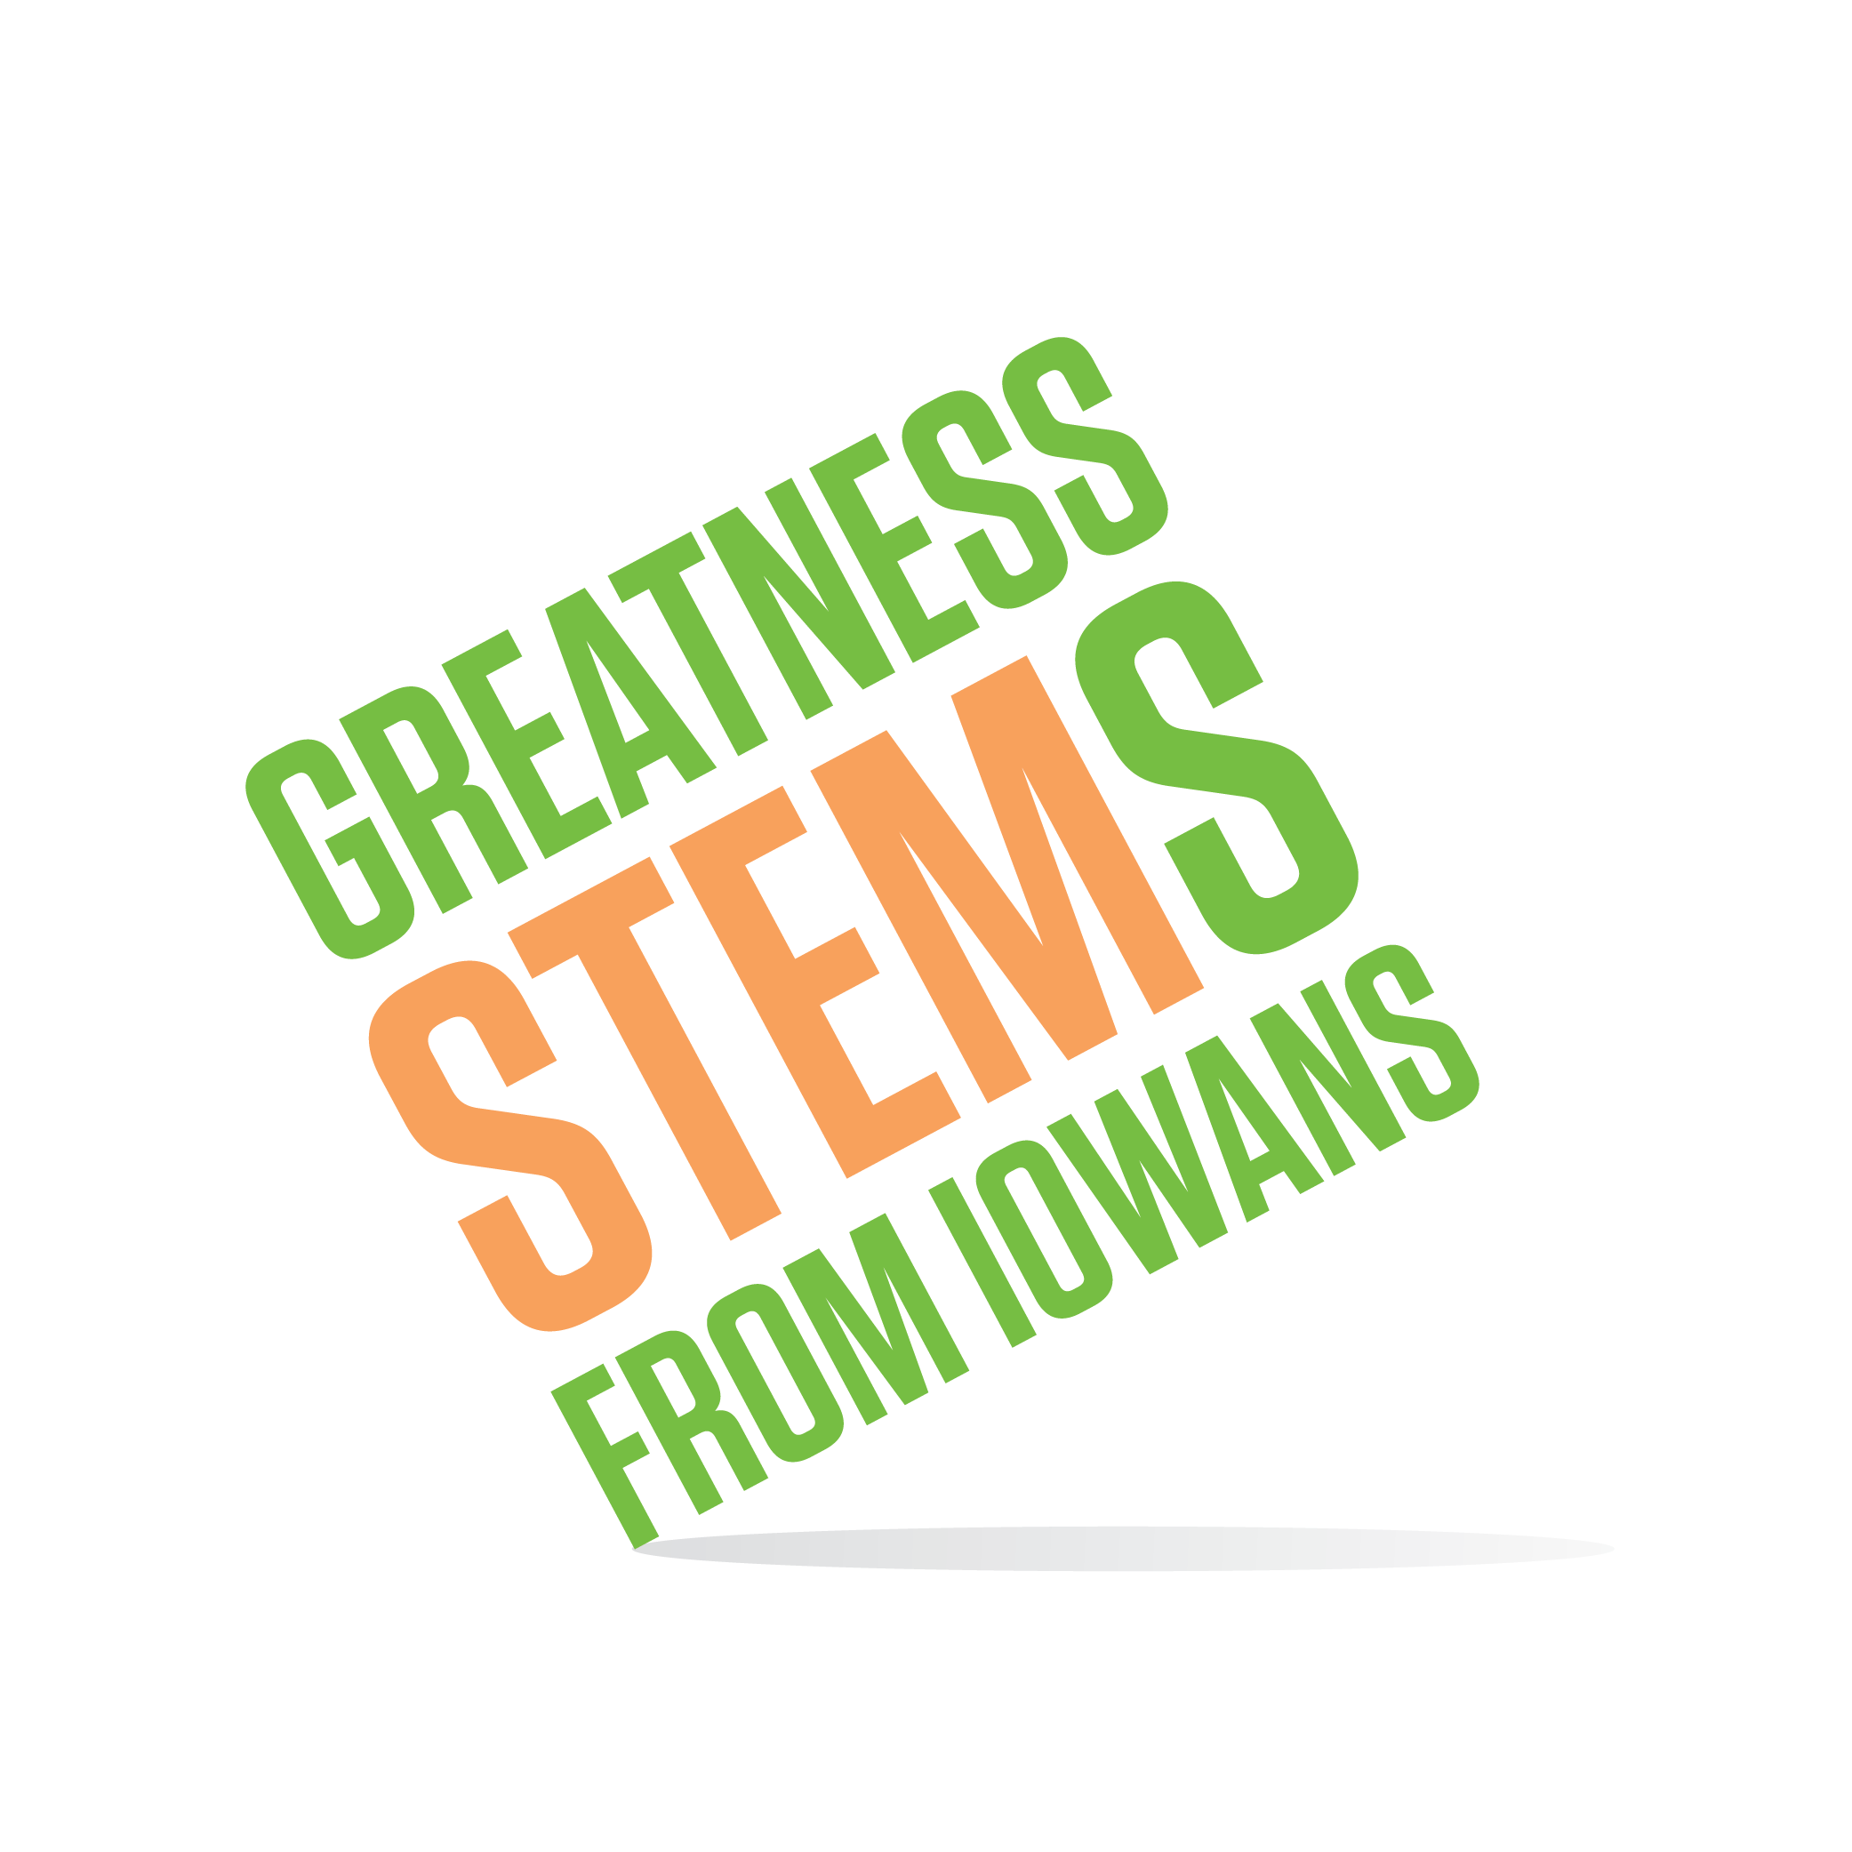
SC Region STEM Advisory Board
January 18, 2017
Central Campus, Des Moines
Multipurpose Room

Wednesday, January 18, 2017
2:00-2:05 | Welcome and introductions  Central Campus Hosts  Sam Oppel Central Campus  Sgt. Douglas Jacobson, US Army
2:05-2:20 | Scale-Up Promotion Plan  Applications open Jan 24-March 3 what tools would help you help us spread the word?
2:20-2:50 | Mid-Year Report Highlights
2:50-3:05 | Cyber Security  Iowa Cyber Security Alliance Symposium highlights  Central Campus Cyber Security
3:05-3:30 | STEM Day at the Capitol  Help us thank our legislators for their support  Scheduling: Meet Feb 20, or after STEM Day at Capitol Feb 16?
3:30-3:50 | Announcements:  Your announcements  Introduction to Sgt. Douglas Jacobson  STEM Day at Capitol Feb 16th 10-2pm  I.O.W.A. STEM Teacher Award Jan. 25th 2pm  IMMAWII Jan 27 and 28  Scale-Up Applications open Jan 24th
3:50 | Adjourn  Optional: Central Campus Tour
Next meetings:
February 16th 2:30pm?
March 15th 2pm

