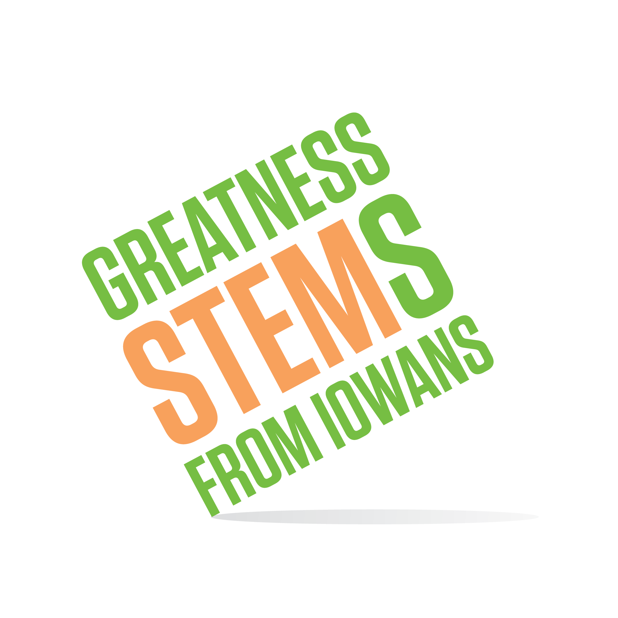
SC/SE Region STEM Advisory Board
June 23, 2016
John Deere Ottumwa Works, Gold Key Room
928 E Vine St, Ottumwa, IA 52501
Virtual attendance: https://uni.zoom.us/j/526876645
Thursday, June 23, 2016
11:00 am | Welcome and Introductions
11:10 | Ottumwa Update from Dwight Dohlman (SE) and Amber Pargmann (SC)
11:00 | Lets compare notes. How does your board handle:  - Board member roles/engagement  - Marketing and communication  - Festivals  - Business Engagement  - Support of STEM awardees (BEST, Scale-Up, etc)
11:45 | Lunch and unstructured conversation
12:15 | Hot topic brainstorm – prioritizing future discussions  What is next? Where would you like to see STEM in 2/5/10 years?
1:00 | Summary and Adjournment

